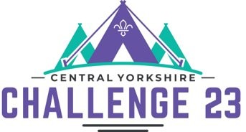

Challenge 23 – Bookings
We are pleased to share details of how to complete your booking for Challenge 23.
You will need to log on to the CYC Challenge 23 booking system at https://bookings.challengecamp.org.uk. This needs to be done by the person who originally logged on.
You will see that the booking system has been updated to allow final bookings to be made.
The screen has also been updated to calculate the camp fees that will be payable to County.
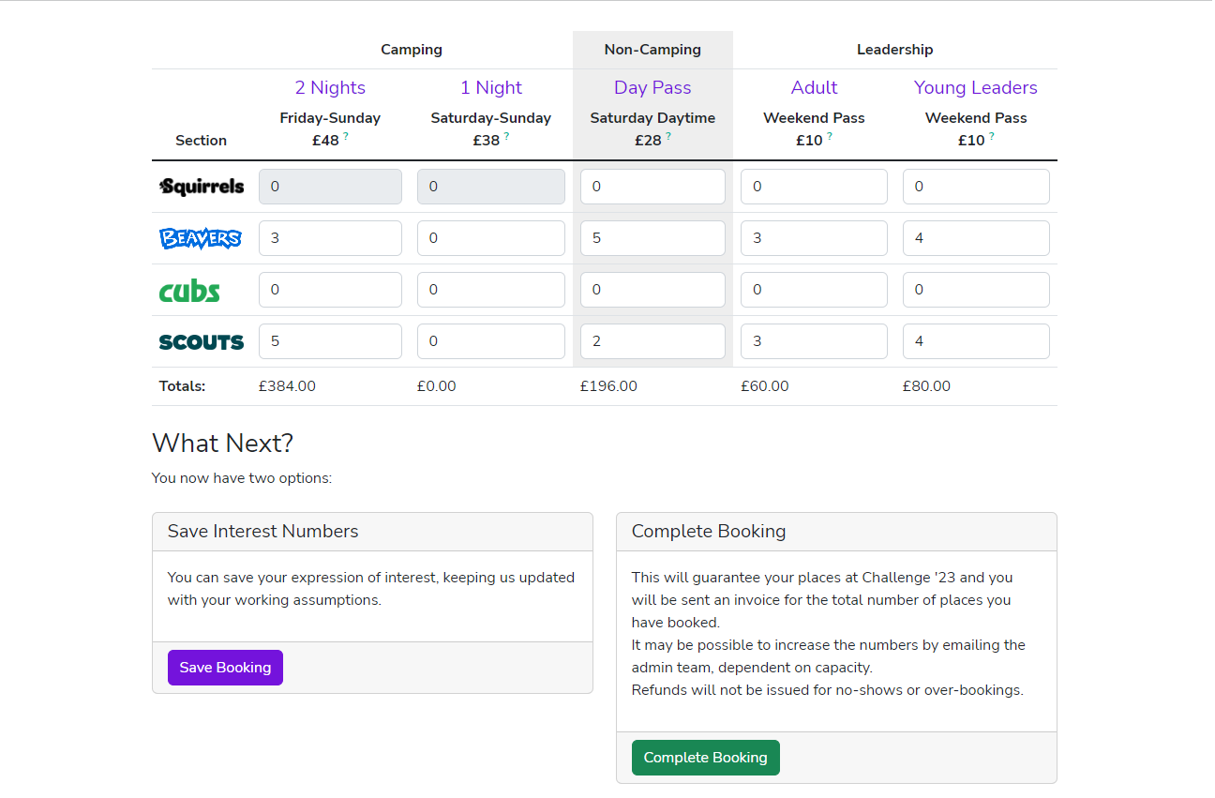

You now have two options:
- Update your estimated numbers. You can update your numbers to keep the Challenge 23 team up to date as often as you want. Use the ‘Save Booking’ option
- Final booking. Before 30th April 2023 you must confirm your final numbers. Once you are happy with your final numbers, use the ‘Complete Booking’ option. Your booking is not submitted until you have completed this process.
If you choose to complete your booking you will be presented with the following screen:
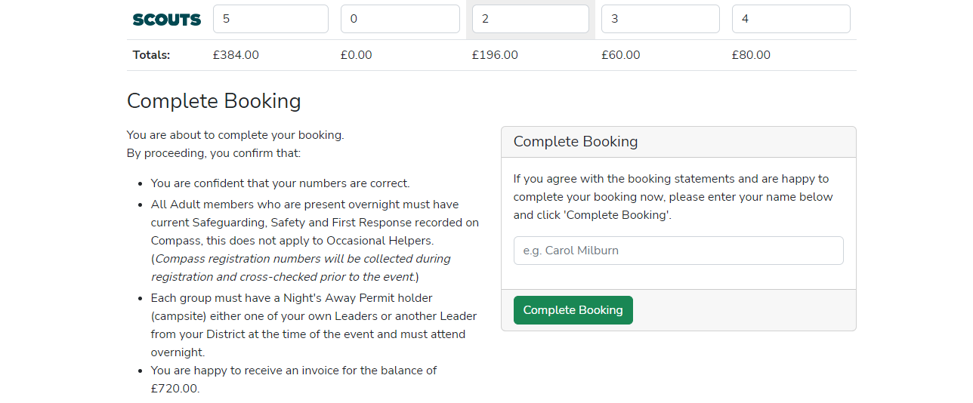
You must click the second ‘Complete Booking’ button after entering your name in order to finalise your booking.

Once you have completed your booking, to make any amendments you will need to email Challenge23bookings@cycscouts.org.uk. You will not be able to edit numbers down.
Once you have completed your booking you will be sent an Invoice for payment for the numbers you have declared. The payment amount will have been shown on screen before you completed your booking. (Full payment will be required for all numbers submitted)
Permission to camp / Health forms
For Challenge 23 we will be collecting Health form information electronically and will not be asking parents to complete a paper permission to camp form.
The electronic data collection will enable us to support your child in the event of incident and will also provide us with relevant permissions for activities the one exception will be Rifle Shooting where we still require a wet signature. As Group Booking Contact, you will collect air rifle shooting permission forms from your members and update the online booking system to show those young people who have permission to take part in this activity. You will need to provide the original shooting permission forms to the camp admin team when you book in your Group on arrival at the event.
The link for Health forms will be sent out in Early May.

